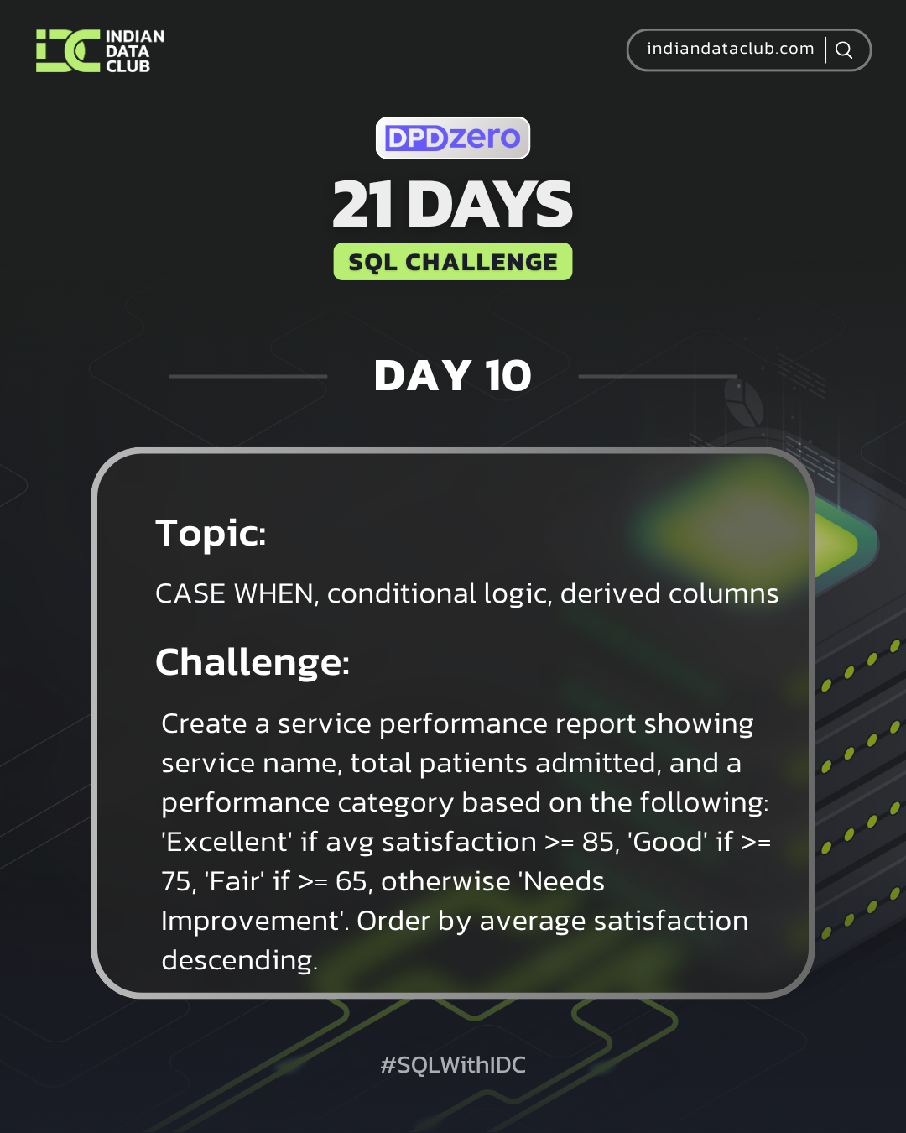

Day-10 SQL Challenge
Day-10 Challenge:
Create a service performance report showing service name, total patients admitted, and a performance category based on the following: 'Excellent' if avg satisfaction >= 85, 'Good' if >= 75, 'Fair' if >= 65, otherwise 'Needs Improvement'. Order by average satisfaction descending.
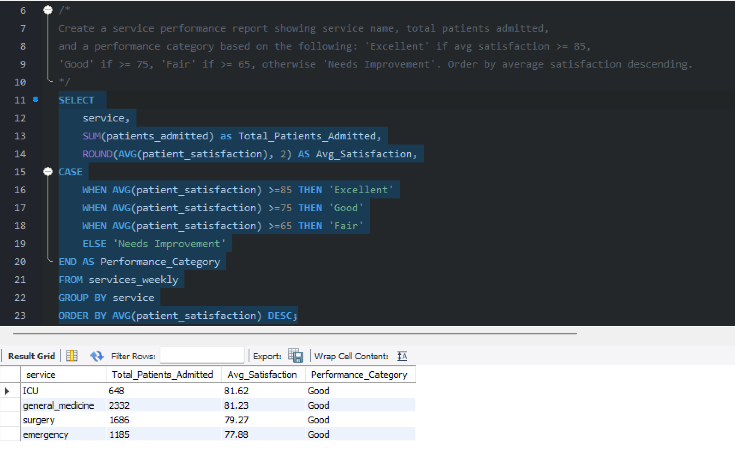

Practice Questions:
1. Categorise patients as 'High', 'Medium', or 'Low' satisfaction based on their scores.
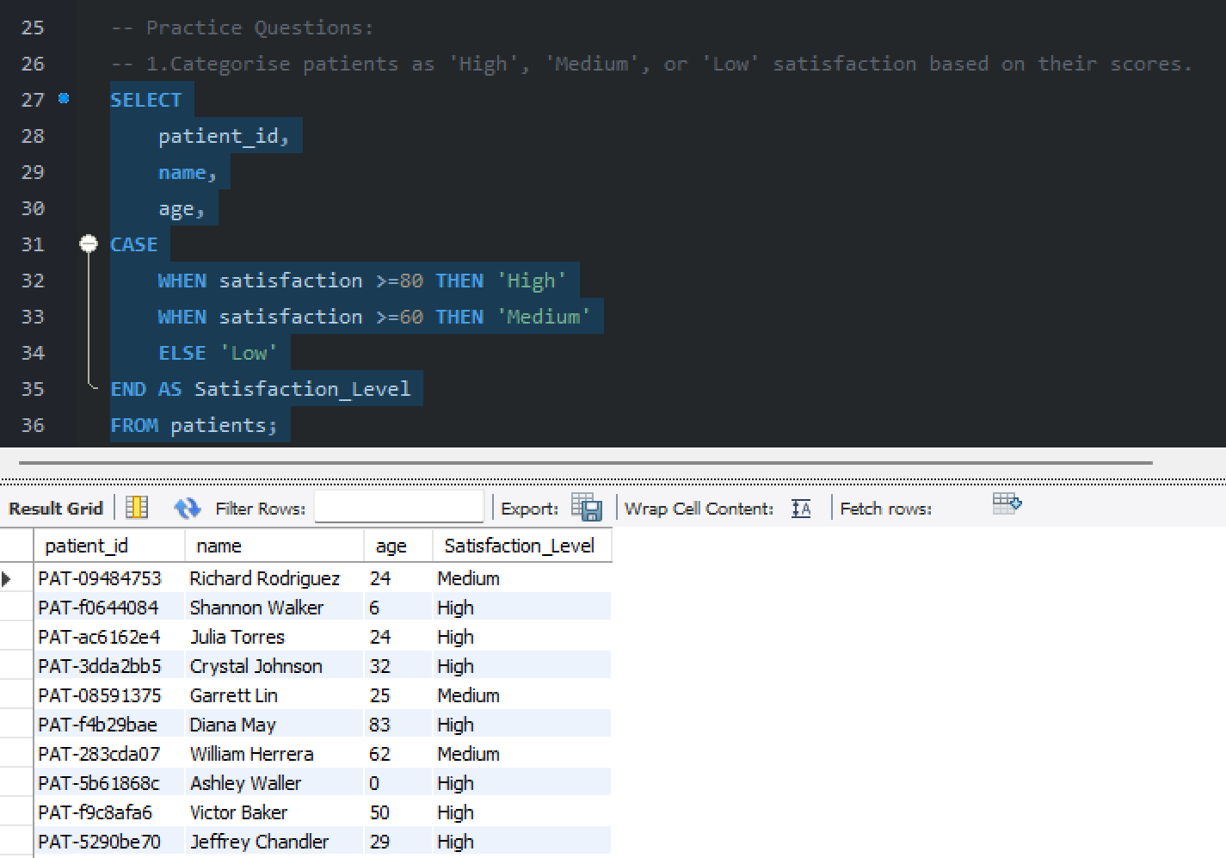
2. Label staff roles as 'Medical' or 'Support' based on role type.
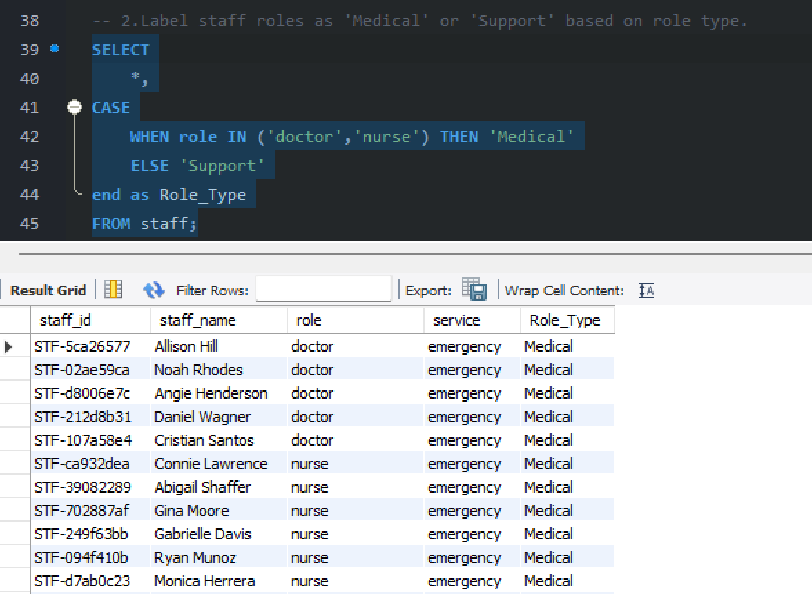

3. Create age groups for patients (0-18, 19-40, 41-65, 65+).
